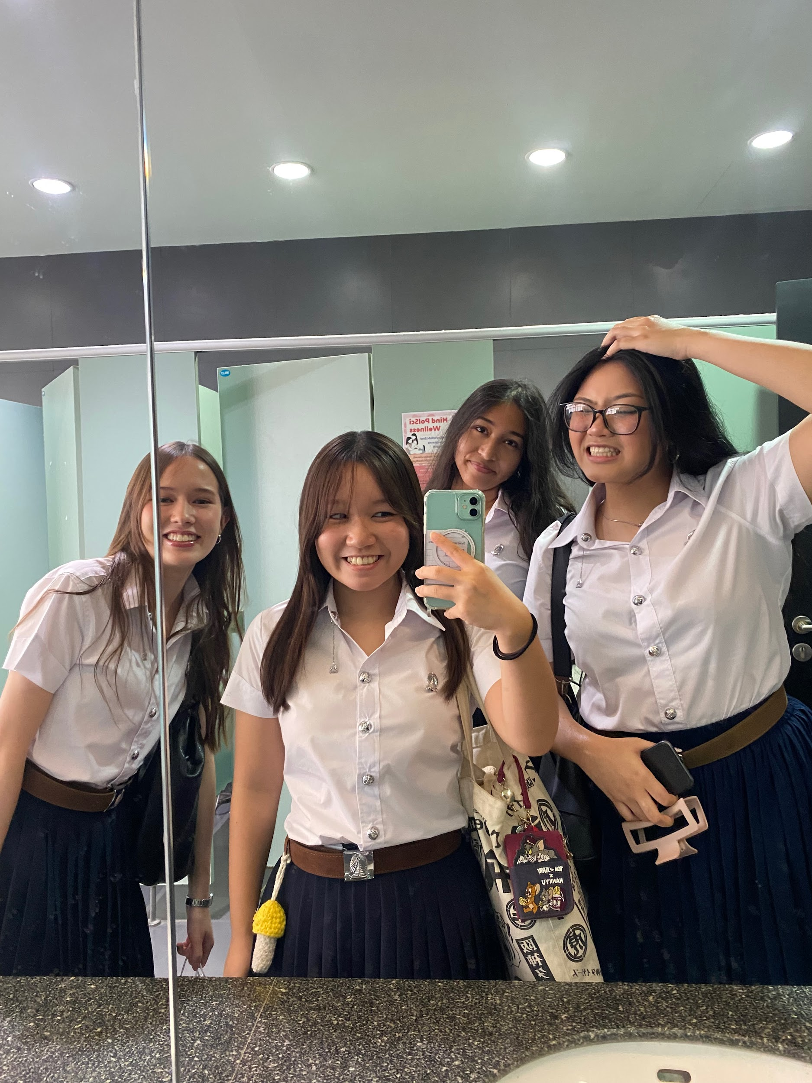

# HANA YOSHIDA (Hana)

My name is Hana Yoshida. I am half Thai Japanese and my Thai name is actually spelled like this ฮานาท์. Growing up, I had the privilege to attend both Thai-Japanese Association schools and international schools. The international nature of my upbringing has given me an ability to accept and understand different perspectives arising from diverse cultures. To be transparent, my pathway toward fluency in English was not an easy one. However, with continuous effort and persistence, English is no longer my “weakness.” Not only that but now it is my special talent that I am fluent in 3 languages. When I was in high school, as a vice head student, I supported students who came from non-English speaking schools and transitioned to an international school environment. Specifically, I shared learning tools that I used that helped me, but most importantly, I provided mental support to those who needed it. Remembering my shaky beginnings gave me the empathy and motivation to actively help other students.

Throughout my years in secondary school, I have always been active in the broader school community and committed to several volunteer services. Though I had no power to change the world, I always put my best effort into making small changes. I have helped raise over 250,000 baht in donations as part of the school animal welfare association within 3 years, in which I was an active member. Additionally, I have visited several local public schools to teach English to students, donated learning supplies, and helped renovate damaged facilities.

During my time in high school, I interned at Bumrungrad International Hospital in Bangkok. At the hospital, I was stationed in the international marketing department, where I got the opportunity to translate hospital website columns from English to Japanese and vice-versa. I took pride and care in this work. However, I was disheartened to consider how the vast majority of citizens are unable to access basic health care. A deeper understanding of political backgrounds of inequality and a broader familiarity with the liberal arts in general, may allow me to affect change in my world. These daily stimulations made me develop a deep interest in liberal arts subjects such as political-science and economics. I was fascinated by how things we learn in class explain the events that are happening in real life. Ultimately, that pretty much explains why I am in PGS right now.



A little bit more about my personal interests, I am a huge matcha enthusiast. Yes, it's my Japanese side coming out. You rarely will see me drinking coffee because of this. In addition to this, I recently got into crocheting. I crochet pretty much anything although my favorite is tops. You can make a custom order with me if you are interested!

Thank you ;)

# 

# NATWARA SOMBOONSUB (Toeihorm)

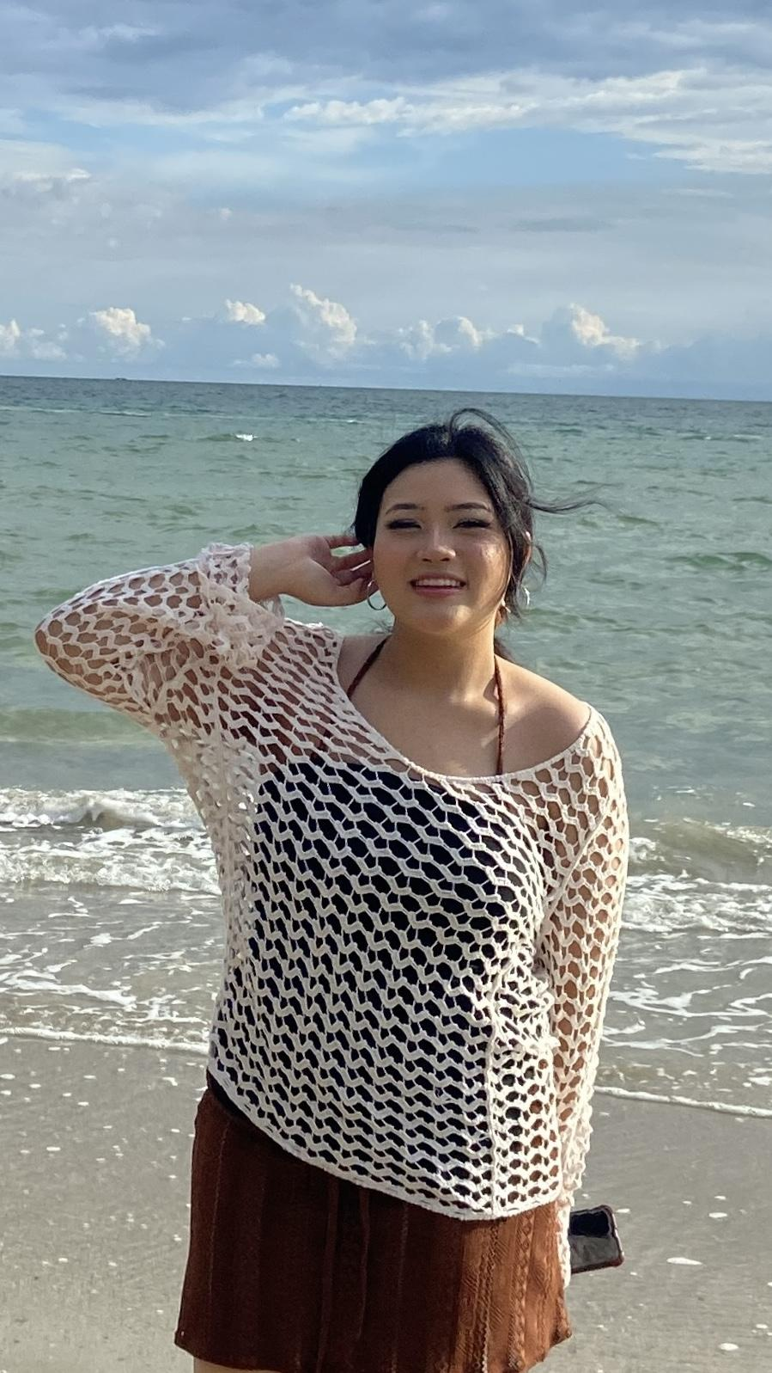

My name is Natwara Somboonsub. My nickname is Toeihorm. I was born on August 17th, 2006. I am the youngest in my family. I have one older brother, and we are 4 years apart. My zodiac sign is Leo. From kindergarten to primary school, I studied at Rajinibon School but in middle school, I moved to Rajini Wipat School. My high school experience was chaotic because in 10th grade, I studied at Rajini Wipat School and then in grade 11 I was an exchange student in Minnesota, United States. But during that time I got the news that my school had closed due to money problems so I had to finish high school at Rajinibon school.

I have always been interested in global situations, politics, and governance. So PGS is the perfect academic pathway for me. I want to learn more about the development of international systems, world economics, urbanization, and migration that variously organize society across the world. I think in today’s world, it’s important to be on trend with everything that happens in our society.

In my personal life, cats are a big part of it. I own 2 cats, 1 boy cat and 1 girl cat. Before owning a cat I would say that I am more of a dog person but I have always been interested in both cats and dogs. After I got a cat my life changed forever. Before owning a cat, I was not a very patient person but with cats, I became more patient and calm. I rarely get mad at my cats because I understand their nature and actions. I love them so much. They are literally my whole world.

# KELIN PAILIN GREGORY (Kelin)

# 

Hello, my name is Kelin Pailin Gregory. I am 17 years old, and I am half Thai and half American and alongside this I have a twin sister named Karla as well. Growing up in a military family I moved often and had the opportunity to experience many different countries, cultures, and schools. Because of this, my idea of “home” was never tied to one place it was always connected to the people I met and the experiences I had along the way. My early high school years were spent at an American school in Zama, Japan, and most recently I studied in the IB program at Szczecin International School in Szczecin, Poland. In these schools I gained many valuable experiences such as working alongside the Japanese Ministry of Foreign Affairs during an international student integration program. I helped facilitate communication and cultural exchange between visiting students and local participants. Adding to this is another important experience to me which was co-founding my school’s anti-bullying club, I led initiatives that not only promoted inclusivity but also strengthened student involvement through creative awareness campaigns and interactive events. Along the same lines as this In an effort to transform the academic environment at my school we had a goal to create a engaging educational atmosphere through curated workshops for younger students, blending both creative and physical activities and this was done by creating a library team in which I led the initiatives. Each move/school shaped the way I see the world, and although it was sometimes difficult to constantly adapt to new environments, I believe it also gave me a broader perspective and an appreciation for global diversity.

Living in so many different countries also made language a challenge. Because we never stayed in one place for long, I often did not have enough time to fully learn and immerse myself in the language of the country I lived in. Instead, I developed a passion for understanding the world around me through history, politics, and the systems that make up societies. This passion has grown into a long-term goal I want to pursue a career in international relations, specifically working toward becoming both an international lawyer and a business owner. I am motivated to use my education and experiences to build connections, promote cooperation, and contribute to meaningful change across borders.

A very important step in this journey is my decision to study at PGS. For me, this is such a rare and important opportunity because firstly it allows me to study in Thailand, a place where I have always had strong ties but was never able to be fully immersed due to my family’s frequent moves. Now I finally have the chance to deepen my connection to Thai culture, language, and traditions while also continuing my academic studies. I also see PGS as such a unique program one unlike anything I have seen before. It allows us to explore many areas of political science, from learning about global affairs to understanding how systems and societies function to connect people on a deeper level. At the same time the double degree program offers the opportunity to expand my experiences beyond one country. I hope to use this chance to strengthen my knowledge of how systems work in another cultural and national context, and to apply that understanding toward my future studies and career.

Through all of these experiences, I have learned the importance of listening, adapting, and working together with people from different backgrounds. I have seen both the beauty of cultural diversity and the challenges of inequality and misunderstanding. These moments have fueled my drive to learn more and to contribute to a world where cooperation and dialogue are valued over conflict. I believe my time at PGS will not only prepare me for my future career but also help me grow as a person who can bridge different cultures and perspectives in meaningful ways.

# ALENA KANTAPURA (Alena)

My name is Alena Kantapura, I’m 18 years old and I’m half Thai, half Indian. To introduce myself, the main things I’m interested in also says a lot about me as a person and I’ve revolved my ECs around them during my time in high school: being an advocate for women, fighting for reproductive justice, politics, as well as working on my nonprofit that focuses on the inequalities within education.

From a young age, I was captivated by global affairs, especially the powerful impact that words and policies have on the world. At eight, I was glued to the TV, watching world leaders at the United Nations, fascinated by how their decisions shaped the policies reaching the lives of millions. By high school, I channeled this interest into meaningful advocacy work, leading discussions on women’s rights and initiating projects focused on reproductive justice and educational disparities. These experiences have given me firsthand insight into the urgency for informed diplomacy and the need for systemic change.

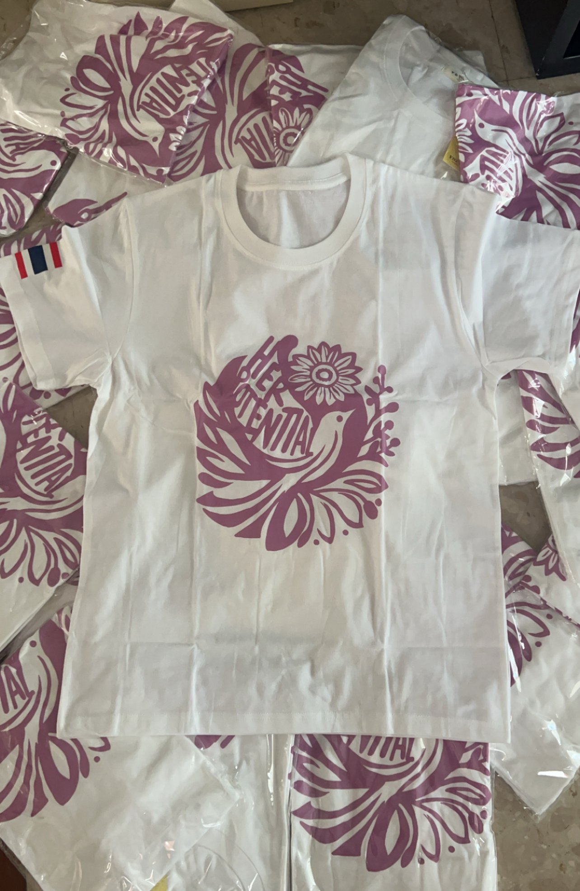

Through my involvement with advocacy groups and nonprofits, such as founding ‘Her Potential,’ a nonprofit dedicated to fundraising to subsidise education for underprivileged women and girls, I’ve seen the power of education and empowerment in transforming communities. Her Potential initially started in Thailand but has now grown globally, with chapters across Europe, Asia, and Oceania. Through projects like these, I’ve developed a passion for tackling the root causes of inequality and injustice.

As I continue my work, I’ve come to realize that actual change requires a deep understanding of political structures and the ability to navigate complex policy issues. It’s this realization that has driven me to pursue a degree in Political Science, for it to act as a foundation for an international legal career within the UN. I decided on PGS specifically because growing up I went to an international school my entire academic journey, and I wasn’t ready to say goodbye to my family, the friends I’ve made along the way and Thailand just yet. This program gives me the opportunity to learn more about this country and how it thrives, before leaving next year.